NIFTi Arm – Quick Reference Manual
(Excerpt of the NIFTi Arm User’s Manual)

NIFTi
Natural Human-Robot Cooperation in Dynamic Environments

www.nifti.eu

Thorsten Linder, Josef Börding
Fraunhofer Institut für Intelligente Analyse- und Informationssysteme – IAIS
Abteilung Adaptive Reflective Teams – ART
Schloss Birlinghoven
53754 Sankt Augustin
josef.boerding@iais.fraunhofer.de

August 2013
Version 0.1

Index
1 The Arm 3
1.1 Introduction 3
1.2 Characteristics 3
2 Interfacing 4
3 ROS Nodes & Usage 4
3.1 First Time Activation 5
4 Recovery Guide for the Motor Controllers 6
5 Safety instructions 7

The Arm

Introduction
The NIFTi arm is an extension "module" for the NIFTi-UGV. It can be mounted as replacement of the battery-cover on top of the robot. The arm has 4 degree of freedom. The two main actuators are lifting upper and lower joint to raise a hight up to ca. 1,20 m in addition to the robot hide. On top of the lower joint is a pan-till-unit (PTU) which can carry additional sensors and swivel those into the direction of choice, e.g. cameras. To support an easy replacement of sensors the PTU has 3 active USB 2.0 port available.
Figure 1: The NIFTi-Arm is composed out of six elements. Starting from bottom up: shoulder, upper arm, elbow, lower arm, wrist and Pan-Tilt-Unit (PTU)

Characteristics
- Power supply: 24 V DC
- Maximum Height: ca. 120 cm (without robot/Absolem height)
- Maximum Payload: 500 g
- Main Arm Interfaces: CAN-to-USB 2.0
- PTU Interfaces: UTAR-to-USB 2.0
- PTU USB-Hub: 3USB 2.0
- Mounting: As replacement of the battery-cover (Absolem only)

Interfacing
The arm can be mounted as replacement of the battery-cover on top of the robot using the four battery cover bolts. The power supply is provided by the NIFTi-Robot (check the manual of BlueBotics Absolem for more information). The Arm comes with a short power cable extender which needs to be mounted to the power supply board of the robot.
Warning! Check for the correct polarity.
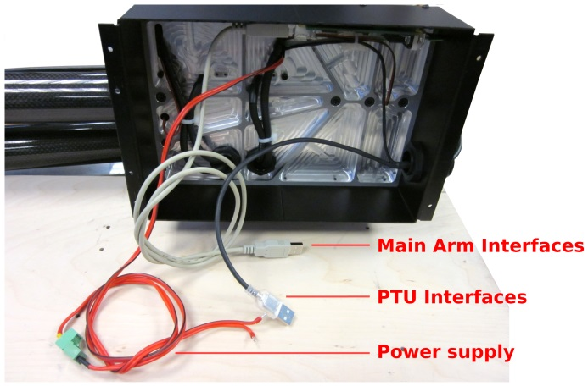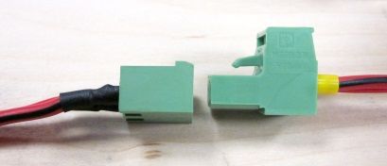
Figure 2: The NIFTi-Arm has three interfaces. The 24V DC power supply interface, a main arm interfaces (CAN-Controller Interface) and a PTU Interface (PTU-controller & PTU USB-Hub)

Furthermore, the main arm interface (USB) and the PTU interface (USB) need to be plugged to the main board. For further configurations see also 3.1.
Note: The Arm is not part of the safety circuit from Absolem. The power supply board does not have a port which can be controlled via the safety circuits. This means the arm cannot be stopped by the safety switch of the robot.

ROS Nodes & Usage
The required Software is available in the NIFTi Subversion at https://subversion.dfki.de/nifti.

First Time Activation
- Check-out the NIFTi SVN. In particular you need these packages:
Package | Folder
nifti arm | nifti drivers
nifti arm msgs | nifti drivers
nifti arm demo gui (optional) | nifti ui
drivers (optional) | code

- Driver installation; in cases where the drivers are not already installed (e.g. on a laptop or a fresh installed robot) you need to follow the instructions from the README files of the driver (located in the folder driver; not nifti driver). In particular the CAN-drivers need to be installed. For this purpose just type:
$ cd cdkl-2.09
$ sudo make clean install

- Compile the NIFTi-arm packages
$ rosmake nifti arm nifti arm demo gui

- Creating the udev-rule for the Arm CAN-Controller and the Absolem CAN-Controller.
By adding the NIFTi-Arm on top of the NIFTi-Robot (Absolem) the System has now two CAN-controllers. The Absolem is configured in such a way that the CAN-controller needs to be enumerated as /de- v/usb/cpc usb0. The NIFTi-Arm is configured in such a way that the CAN-controller needs to be enumerated as /dev/usb/cpc usb1. For more details on how-to-do check chapter Fehler! Verweisquelle konnte nicht gefunden werden..

- Check-out and Install PTU motor drivers
$ cd <any local ros-package-path location>
$ mkdir dynamixel motor && cd dynamixel motor
$ svn co https://ua-ros-pkg.googlecode.com/svn/stacks/dynamixel_motor/trunk
(for more information check http://www.ros.org/wiki/dynamixel_controllers)
$ rosmake dynamixel controllers

- First time starting
- Ensure the arm is folded together like depict in figure 1, then start the main driver
$ roslaunch nifti arm arm.launch
- and start the demonstration GUI
$ roslaunch nifti arm demo gui node.launch

Recovery Guide for the Motor Controllers
In cases where the motor controllers need to be reconfigured/recovered or where settings must be changed, you will need to use a windows PC and a suitable serial flashing cable.
At first download the ELMO Composer software (http://www.elmomc.com/products/software-tools-main.htm) and the configuration file (take a look at the NIFTi-SVN File: //nifti_drivers/trunk/nifti_arm/recovery-files).
Remove the motor controller cover (the black plastic box on top of the arm base). Then, for each controller you need to perform the following steps:
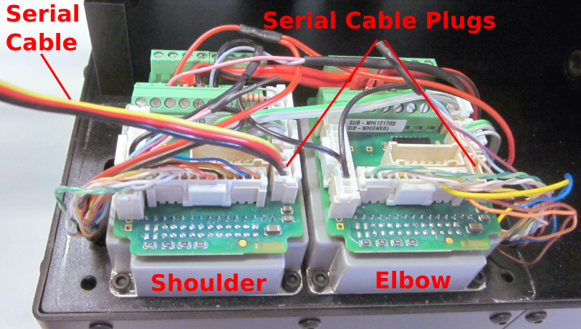
Figure 3: The two main motor controller of the arm.
Left: shoulder controller; right: elbow controller
- Connect the serial cable to the targeted motor controller (see Figure 3).
- Use the Composer to flash the motor controller with the configuration provided by the configuration file (.dat file). Ensure to use the correct file for the targeted controller. If you mix up the configuration the motor directions will be inverted, i.e. the arm will malfunction.
- Use the console provided by the Composer software and type
PP[13]=<CAN-ID>;
PP[14]=<CAN-BAUD>;
MO=0;
SV;
The variable <CAN-ID> is 20 for shoulder or 21 for elbow.
The variable <CAN-BAUD> is 1 by default, which is equivalent to 500kbit/s.
- Check the settings by un-powering the device, waiting for 10 seconds and re-powering. Then type the following in to the Composer console, to see the stored values:
PP[13]=<CAN-ID>;
PP[14]=<CAN-BAUD>;
The returned values should be equal to the commanded ones.

Safety instructions
- Do not use the arm in an erected mode while driving.
- Do not use the arm without line of view or a safety personal. The Blue-Botic Absolem robot does not support an emergency switch function for the arm.
- The build-in USB-Hub is actively powered. However it may happens that the supported current is not enough to power all your devices.
- The Arm is designed to lift sensors in a vertical means. It is NOT designed to manipulated objects or to stretch/move the sensors horizontal. This means using the arm in such a way that the center of gravity is not only vertically moved may causes damages to the arm.
- The extra weight of the arm moves the center of gravity of the robot and can unbalance it.
- Do not fall on the arm.
- Do not crash or collide.

